SCHOOL OF COMPUTER SCIENCE AND ARTIFICIAL INTELLIGENCE |  |  |  |  | DEPARTMENT OF COMPUTER SCIENCE ENGINEERING
Program Name: B. Tech |  |  |  | Assignment Type: Lab |  |  | Academic Year:2025-2026
Course Coordinator Name |  |  |  | Venkataramana Veeramsetty
Instructor(s) Name |  |  |  | Dr. V. Venkataramana (Co-Ordinator)  Dr. T. Sampath Kumar  Dr. Pramoda Patro  Dr. Brij Kishor Tiwari  Dr.J.Ravichander  Dr. Mohammand Ali Shaik  Dr. Anirodh Kumar  Mr. S.Naresh Kumar  Dr. RAJESH VELPULA  Mr. Kundhan Kumar  Ms. Ch.Rajitha  Mr. M Prakash  Mr. B.Raju  Intern 1 (Dharma teja)  Intern 2 (Sai Prasad)  Intern 3 (Sowmya)  NS_2 ( Mounika)
Course Code |  |  | 24CS002PC215 | Course Title |  | AI Assisted Coding
Year/Sem |  |  | II/I | Regulation |  | R24
Date and Day  of Assignment |  |  | Week2 - Monday | Time(s)
Duration |  |  | 2 Hours | Applicable to  Batches
Assignment Number:4.1(Present assignment number)/24(Total number of assignments)
 | Q.No. | Question |  |  |  |  |  | Expected Time  to complete
 | 1 | Lab 4: Advanced Prompt Engineering – Zero-shot, One-shot, and Few-shot Techniques  Lab Objectives:  - To explore and apply different levels of prompt examples in AI-assisted code generation.  - To understand how zero-shot, one-shot, and few-shot prompting affect AI output quality.  - To evaluate the impact of context richness and example quantity on AI performance.  - To build awareness of prompt strategy effectiveness for different problem types.  Lab Outcomes (LOs):  After completing this lab, students will be able to:  - Use zero-shot prompting to instruct AI with minimal context.  - Use one-shot prompting with a single example to guide AI code generation.  - Apply few-shot prompting using multiple examples to improve AI responses.  - Compare AI outputs across the three prompting strategies.  Task #1 – Zero-Shot Prompting with Conditional Validation  Objective  Use zero-shot prompting to instruct an AI tool to generate a function that validates an Indian mobile number.  Requirements  - The function must ensure the mobile number:  - Starts with 6, 7, 8, or 9  - Contains exactly 10 digits  Expected Output  - A valid Python function that performs all required validations without using any input-output examples in the prompt.  Prompt:  write a function in python which checks if indian mobile number is valid or not and takes input and prints output  code:  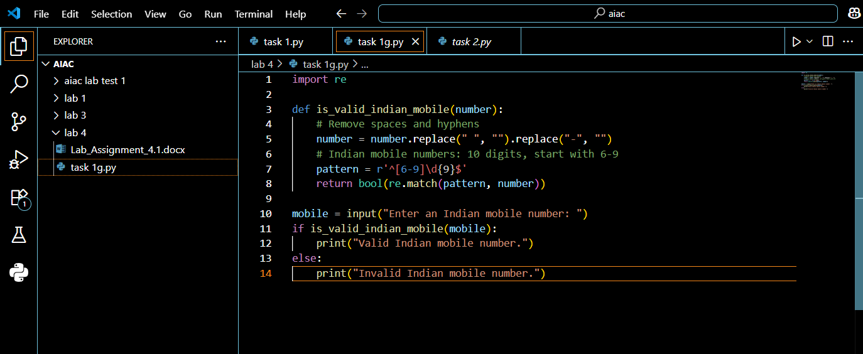  Output:  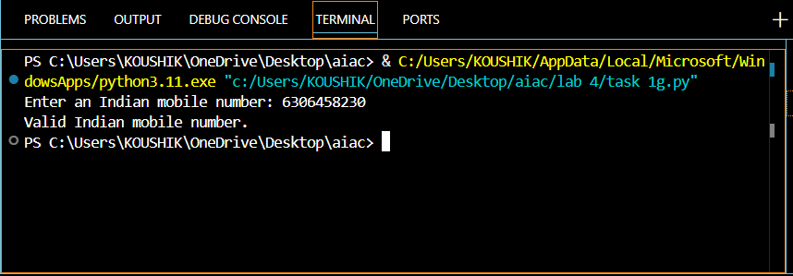  Code explanation:  This code checks if a given input is a valid Indian mobile number. Here’s how it works:  - It imports the re module for regular expressions.  - The function is_valid_indian_mobile(number):  - Removes spaces and hyphens from the input.  - Uses a regex pattern to check if the number has exactly 10 digits and starts with a digit from 6 to 9 (the valid starting digits for Indian mobile numbers).  - Returns True if the number matches the pattern, otherwise False.  - The script asks the user to enter a mobile number, checks its validity using the function, and prints whether it is valid or not.  In cursor:  Prompt:  write a function in python which checks if indian mobile number is valid or not and the function must ensure the mobile number Starts with 6, 7, 8, or 9 and Contains exactly 10 digits and takes input and prints output  Code:  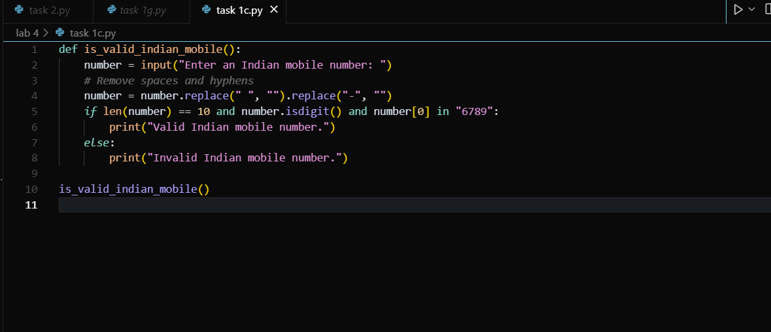  Output:  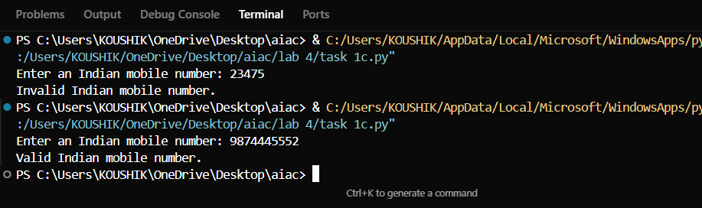  Code explanation:  The function is_valid_indian_mobile() checks if a user-input mobile number follows the standard Indian mobile number format. Removes any spaces and hyphens from the input to handle formatted numbers like "98765-43210" or "987 654 3210".  The number is valid if it meets ALL three conditions:  - Length: Exactly 10 digits  - Digits only: Contains only numeric characters (0-9)  - Starting digit: First digit must be 6, 7, 8, or 9  Task #2 – One-Shot Prompting with Edge Case Handling  Objective  Use one-shot prompting to generate a Python function that calculates the factorial of a number.  Requirements  - Provide one sample input-output pair in the prompt to guide the AI.  - The function should handle:  - 0! correctly  - Negative input by returning an appropriate message  Expected Output  - A Python function with correct factorial logic and edge case handling, generated from a single example.  Prompt:  genarate a python function that calculates the factorial of a number The function should handle 0! correctly and Negative input by returning an appropriate message and it should take an input and print the output , example: input = 5 output =120  Code:  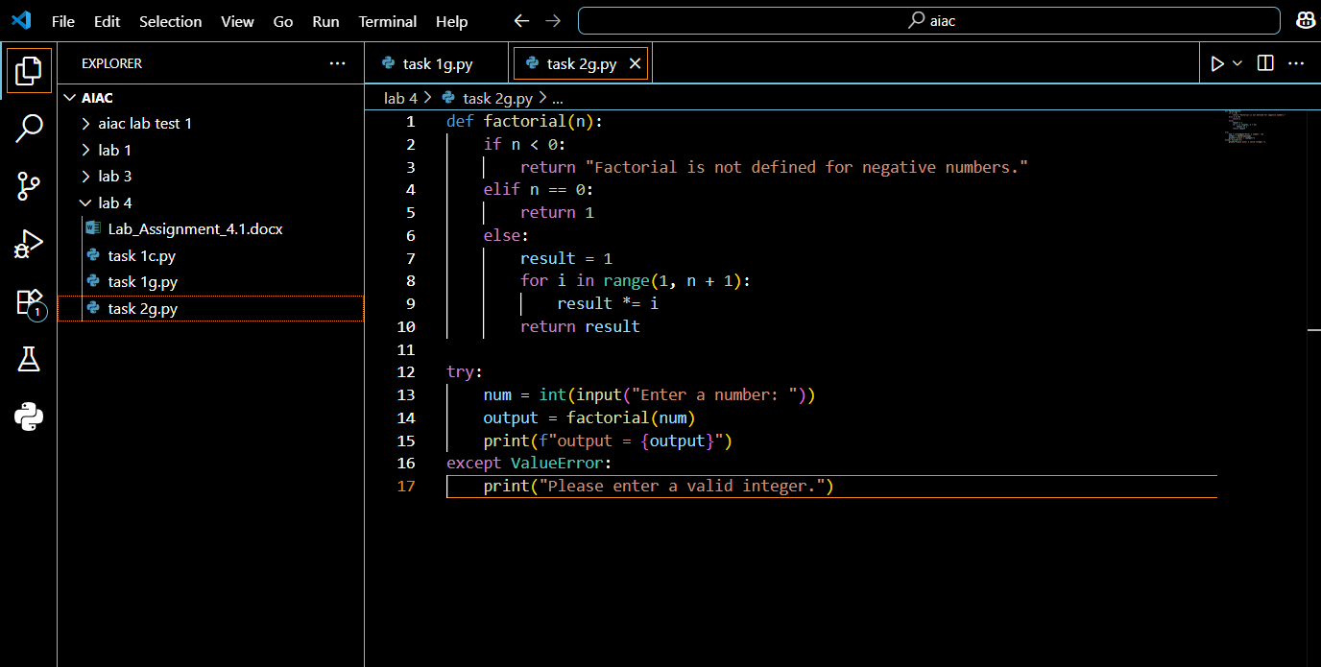  Output:  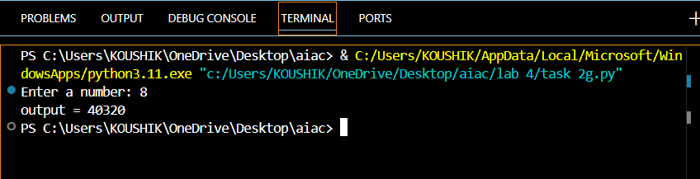  Code explanation:  This code calculates the factorial of a given number entered by the user. Here’s how it works:  - The factorial(n) function:  - Returns an error message if the input is negative (since factorial is not defined for negative numbers).  - Returns 1 if the input is 0 (since 0! = 1).  - Otherwise, it calculates the factorial by multiplying all integers from 1 to n.  - The script asks the user to enter a number.  - It tries to convert the input to an integer and calls the factorial function.  - If the input is not a valid integer, it prints an error message.  - The result (or error message) is printed as output = ....  In cursor:  Prompt:  genarate a python function that calculates the factorial of a number The function should handle 0! correctly and Negative input by returning an appropriate message and it should take an input and print the output , example: input = 3 output =6 and import math for fast execution  Code:  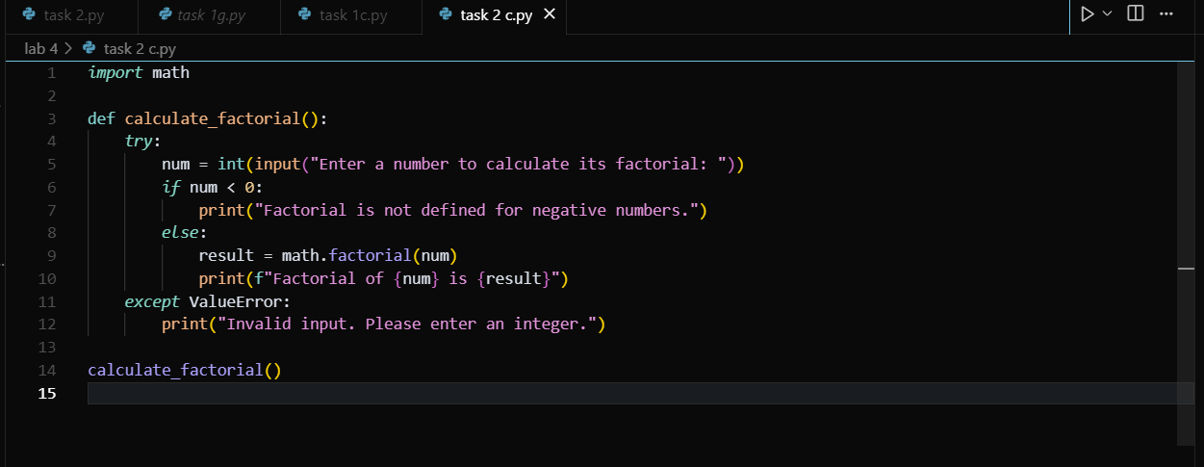  Output:  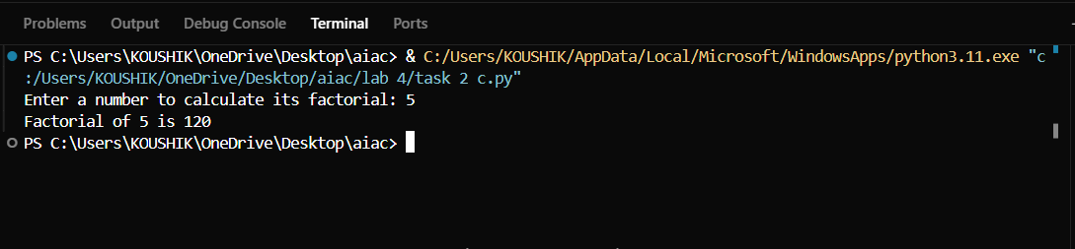  Code explanation:  The function calculate_factorial() takes user input and calculates the factorial of that number using Python's built-in math module.  Task #3 – Few-Shot Prompting for Nested Dictionary Extraction  Objective  Use few-shot prompting (2–3 examples) to instruct the AI to create a function that parses a nested dictionary representing student information.  Requirements  - The function should extract and return:  - Full Name  - Branch  - SGPA  Expected Output  - A reusable Python function that correctly navigates and extracts values from nested dictionaries based on the provided examples  Prompt:  create a function that parses a nested dictionary representing student information. The function should extract and return Full Name,Branch,SGPA  example:  Input:  Full Name': 'Arjun Mehta',  'Branch': 'Computer Science',  'SGPA': 8.7  Input 2:  Full Name': 'Sneha Reddy',  'Branch': 'Electronics',  'SGPA': 9.2  when printing the details it shold just print them or take an input  this function should take multiple inputs and give output  Code:  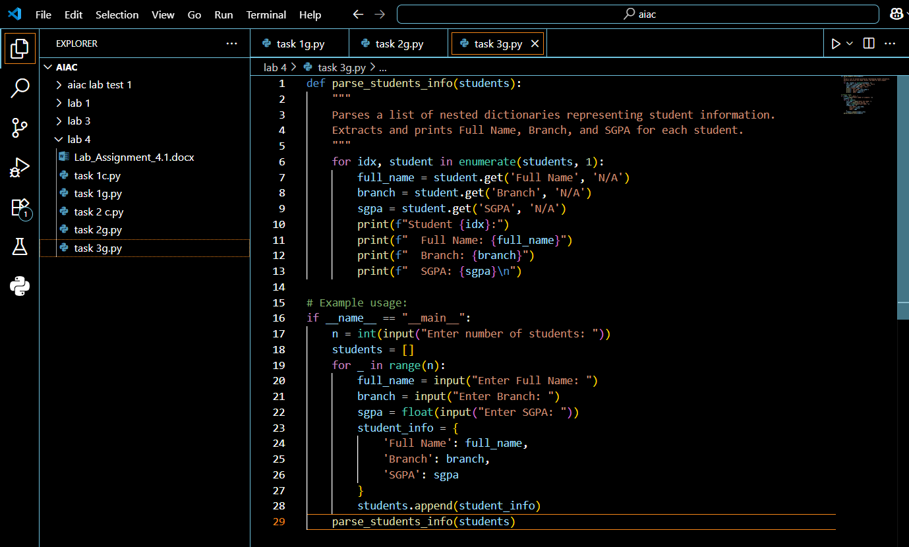  Output:  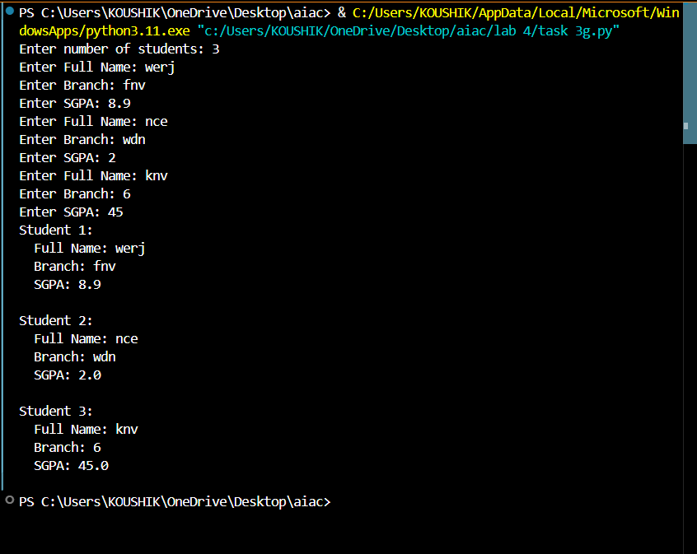  Explanation:  This code calculates the factorial of a given number entered by the user. Here’s how it works:  - The factorial(n) function:  - Returns an error message if the input is negative (since factorial is not defined for negative numbers).  - Returns 1 if the input is 0 (since 0! = 1).  - Otherwise, it calculates the factorial by multiplying all integers from 1 to n.  - The script asks the user to enter a number.  - It tries to convert the input to an integer and calls the factorial function.  - If the input is not a valid integer, it prints an error message.  - The result (or error message) is printed as output = ...  In cursor:  Prompt:  create a function that parses a nested dictionary representing student information. The function should extract and return Full Name,Branch,SGPA  example:  Input:  Full Name': 'Arjun Mehta',  'Branch': 'Computer Science',  'SGPA': 8.7  Input 2:  Full Name': 'Sneha Reddy',  'Branch': 'Electronics',  'SGPA': 9.2  when printing the details it shold just print them or take an input  this function should take multiple inputs and give output  Code:  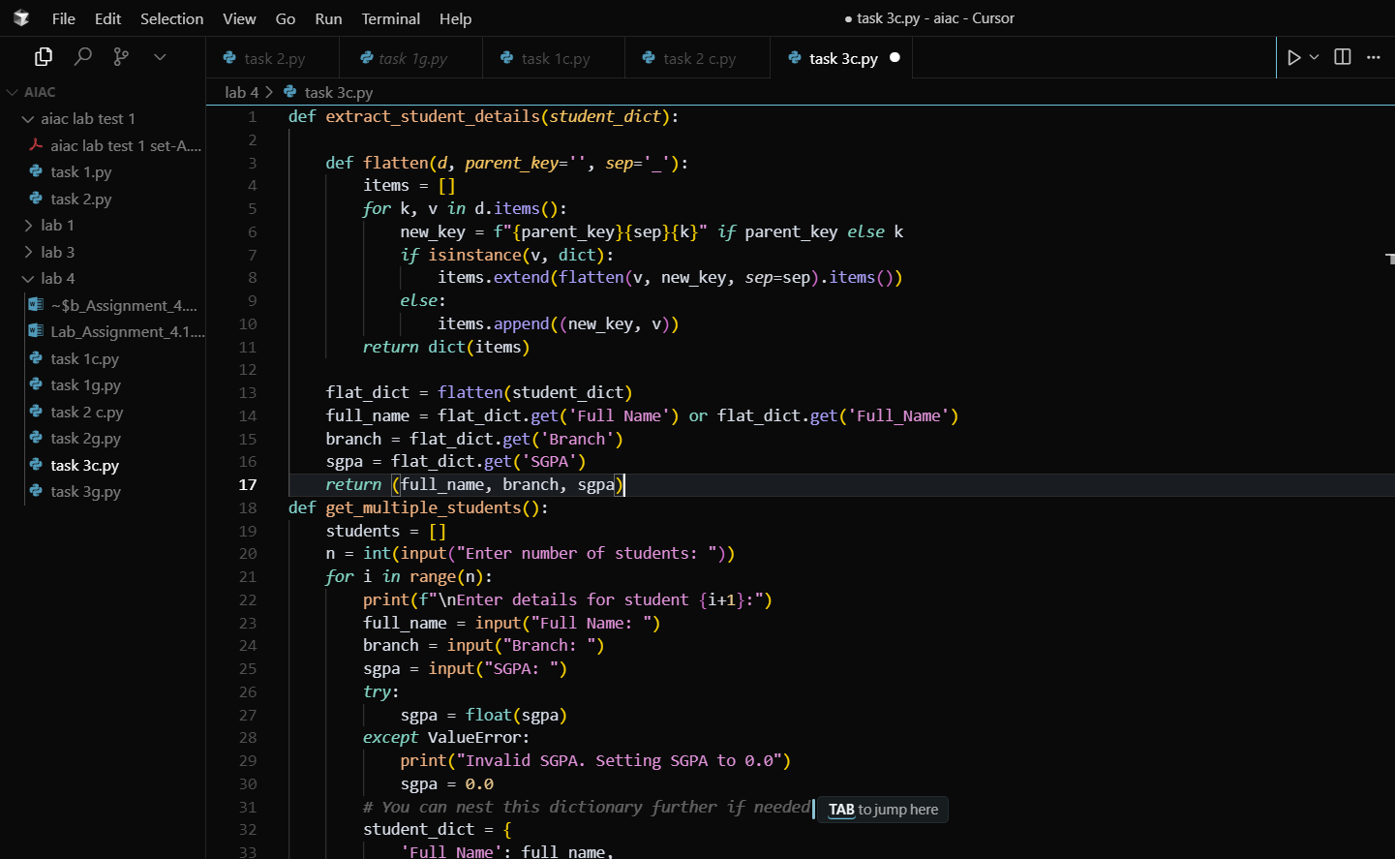  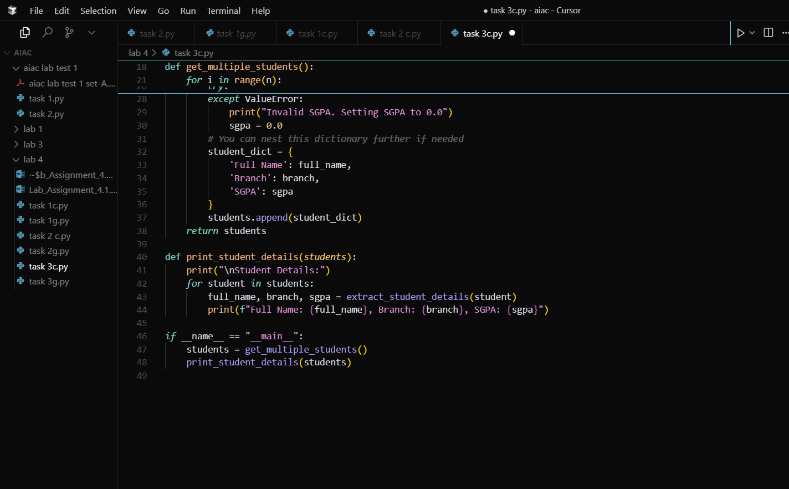  Output:  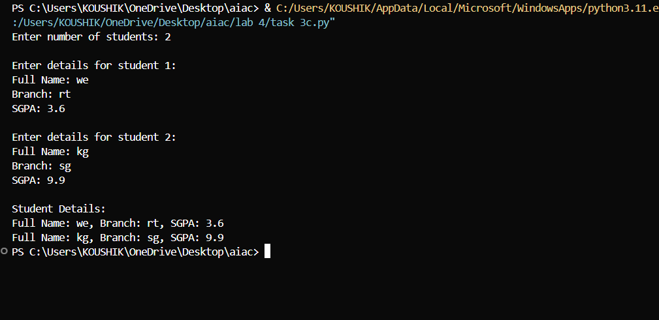  Explanation:  What this script does  - Collects details for multiple students from user input  - Extracts each student’s full name, branch, and SGPA (even if nested inside sub-dictionaries)  - Prints the details in a uniform format  Task #4 – Comparing Prompting Styles for File Analysis  Objective  Experiment with zero-shot, one-shot, and few-shot prompting to generate functions for CSV file analysis.  Requirements  - Each generated function should:  - Read a .csv file  - Return the total number of rows  - Count the number of empty rows  - Count the number of words across the file  Expected Output  - Working Python functions for each prompting style, with a brief reflection comparing their accuracy, clarity, and efficiency.  zero-shot:  Prompt:  generate functions for CSV file analysis. Each generated function should Read a .csv file, Return the total number of rows, Count the number of empty rows,Count the number of words across the file ,it should read the file task4.txt and print the output  Code:  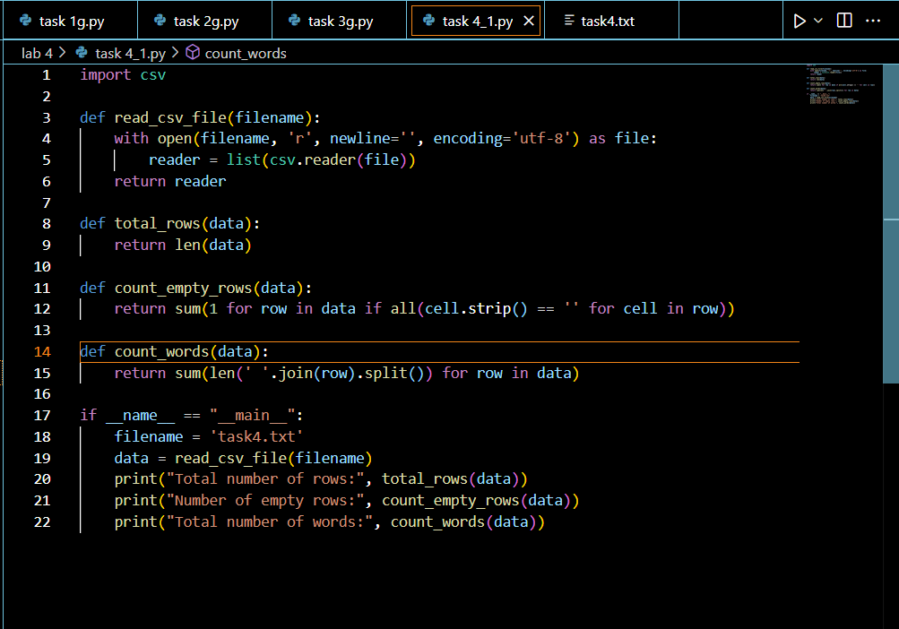  Output:  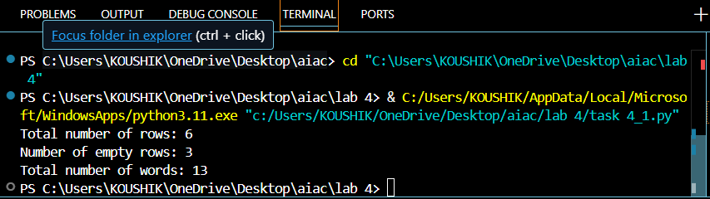  one-shot:  Prompt:  generate functions for CSV file analysis. Each generated function should Read a .csv file, Return the total number of rows, Count the number of empty rows,Count the number of words across the file ,it should read the file task4.txt and print the output Example: For a file with rows [“hello world”] and [“ ”], the output is total_rows=2, empty_rows=1, total_words=2.  Code:  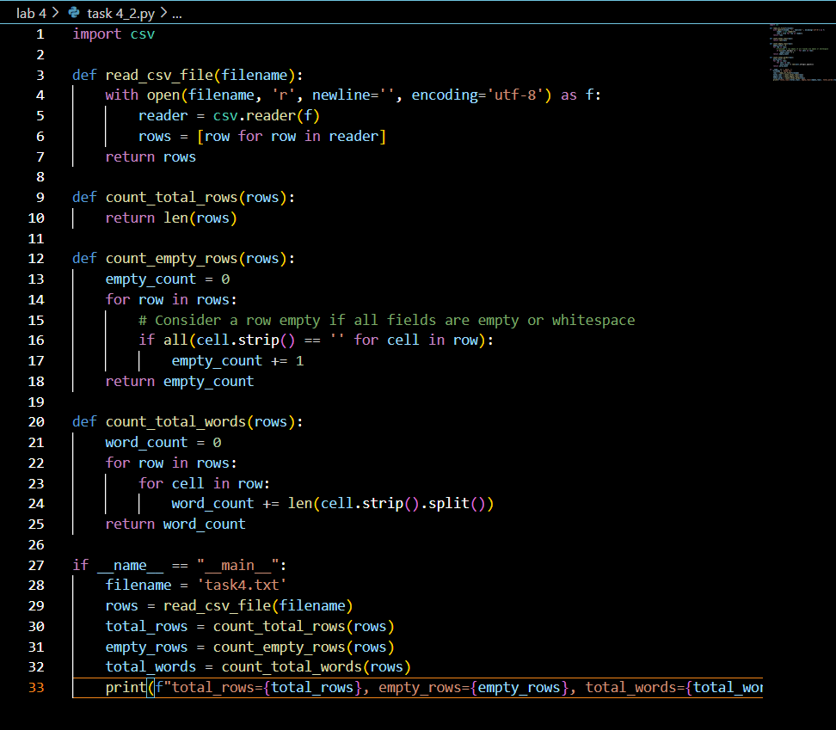  Output:  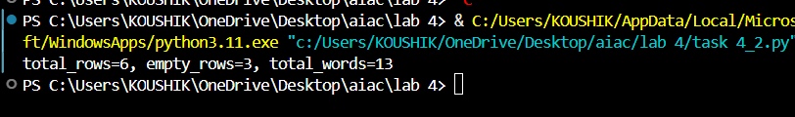  few-shot prompting:  Prompt:  generate functions for CSV file analysis. Each generated function should Read a .csv file, Return the total number of rows, Count the number of empty rows,Count the number of words across the file ,it should read the file task4.txt and print the output ,  Example 1: Input [“Hi there”] → rows=1, empty=0, words=2.  Example 2: Input [“”] → rows=1, empty=1, words=0.  Example 3: Input [“Good morning”, “ ”] → rows=2, empty=1, words=2.  Now generalize.  Code:  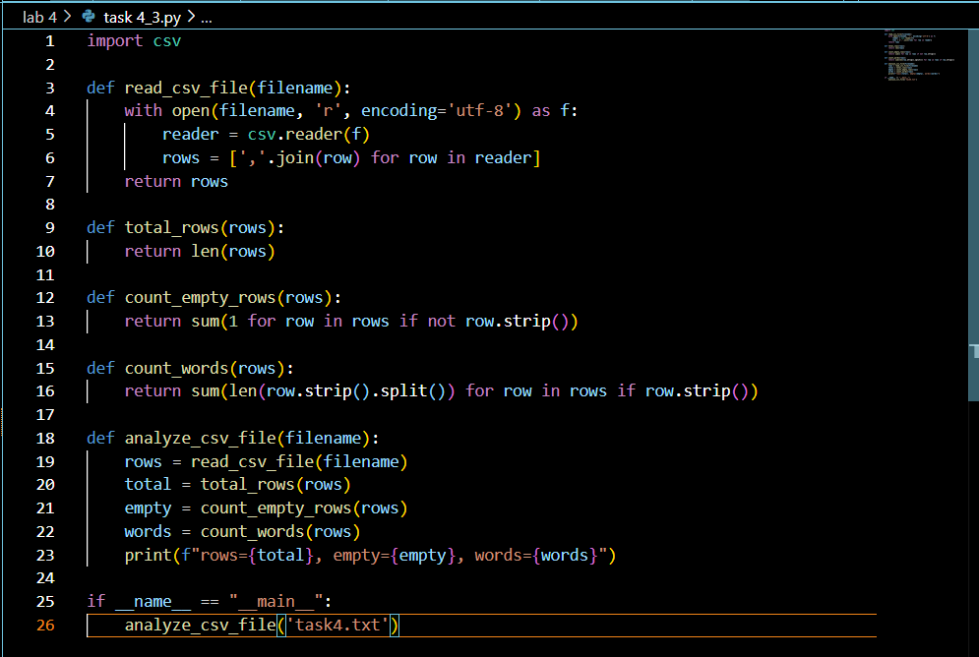  Output:  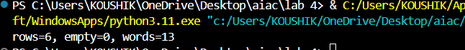  Task #5 – Few-Shot Prompting for Text Processing and Word Frequency  Objective  Use few-shot prompting (with at least 3 examples) to generate a Python function that processes text and analyzes word frequency.  Requirements  The function must:  - Accept a paragraph as input  - Convert all text to lowercase  - Remove punctuation  - Return the most frequently used word  Expected Output  - A functional Python script that performs text cleaning, tokenization, and returns the most common word using only the examples provided in the prompt  Prompt:  generate a Python function that processes text and analyzes word frequency. The function must Accept a paragraph as input, Convert all text to lowercase, Remove punctuation, Return the most frequently used word  Example 1:  Input: "Hello hello world!"  Output: "hello" (since "hello" appears 2 times, more than "world").  Example 2:  Input: "Python, python; PYTHON is great."  Output: "python" (case-insensitive, punctuation removed).  Example 3:  Input: "I love AI. AI is the future, and AI is fun!"  Output: "ai" (appears 3 times).  Now write a Python function that accepts a paragraph, converts text to lowercase, removes punctuation, and returns the most frequent word.that takes input and prints output  Code:  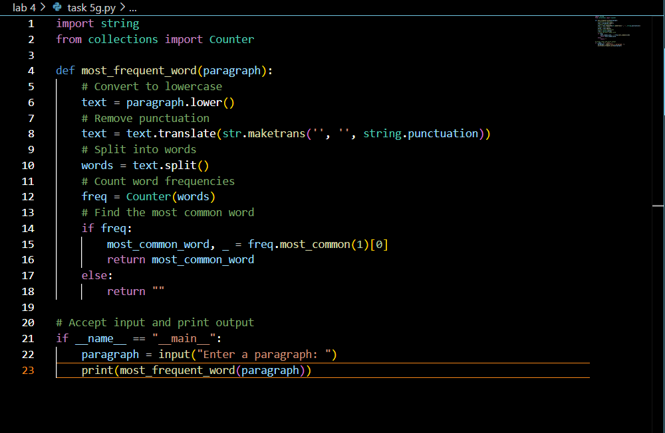  Output:  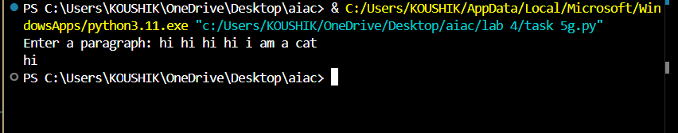  In Cursor:  Prompt:  generate a Python function that processes text and analyzes word frequency. The function must Accept a paragraph as input, Convert all text to lowercase, Remove punctuation, Return the most frequently used word  Example 1:  Input: "Hello hello world!"  Output: "hello" (since "hello" appears 2 times, more than "world").  Example 2:  Input: "Python, python; PYTHON is great."  Output: "python" (case-insensitive, punctuation removed).  Example 3:  Input: "I love AI. AI is the future, and AI is fun!"  Output: "ai" (appears 3 times).  Now write a Python function that accepts a paragraph, converts text to lowercase, removes punctuation, and returns the most frequent word.that takes input and prints output and call the function  Code:  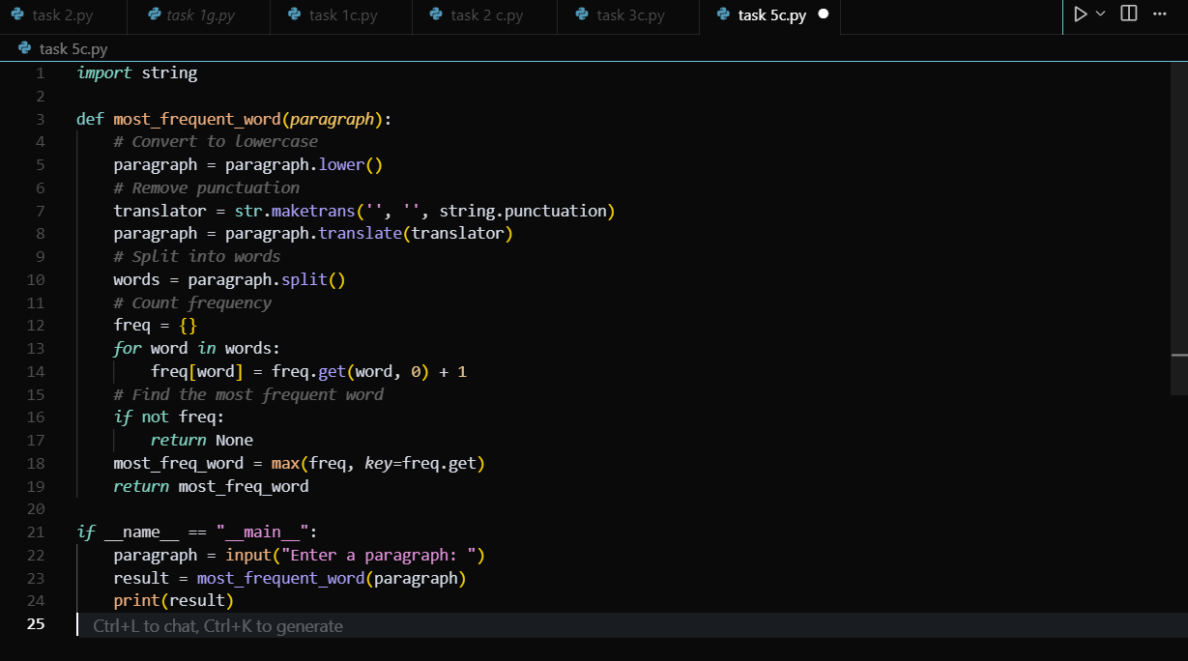  Output:  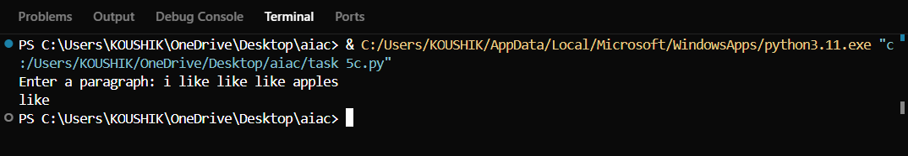  Differences:  Git:  - Uses collections.Counter, a built-in tool specialized for counting hashable items.  - freq.most_common(1) directly gives you the most frequent word and its count.  - More concise, efficient, and Pythonic  - Returns an empty string "" if no words exist.  Cursor:  - Manually builds the frequency dictionary using .get().  - Uses max(freq, key=freq.get) to find the word with the highest count.  - More explicit and beginner-friendly, but slightly longer.  - Returns None if no words exist.  Note: Report should be submitted a word document for all tasks in a single document with prompts, comments & code explanation, and output and if required, screenshots  Evaluation Criteria:  Criteria Max Marks  Zero Shot (Task #1) 0.5  One Shot (Task#2) 0.5  Few Shot (Task#3, Task#4 & Task #5) 1.5  Total 2.5 Marks |  |  |  |  |  | Week2 - Monday

